**Creating Infrastructure in AWS**

* To create infra in AWS we have three possible ways
* Console => Manual
* CLI => Scripted/Procedural
* Cloud formation => Infrastructure as Code (IaC) / Declarative
* AWS Cloud formation is an IaC which helps in provisioning infra at scale declarativly
* Process of Creating Infra using AWS CloudFormation
* Identify the resource to be created
* Identify the variables
* Author/Write/Create an AWS Cloudformation template in JSON/YAML files
* Once the template is ready, then create a CloudFormation Stack to deploy the application.
* Lets try to see one example  
  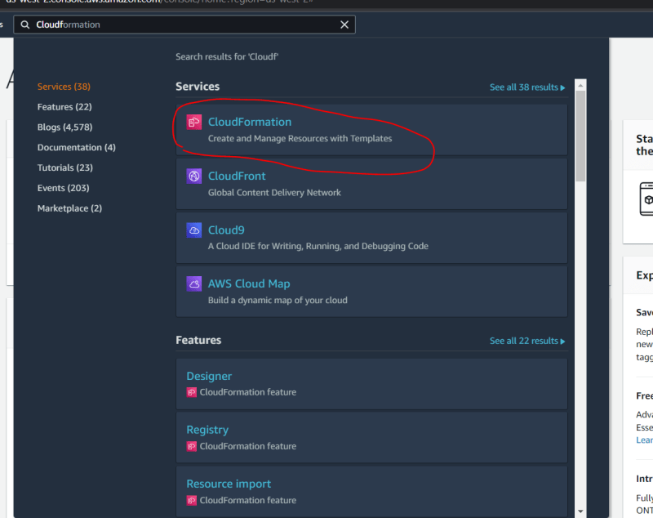  
  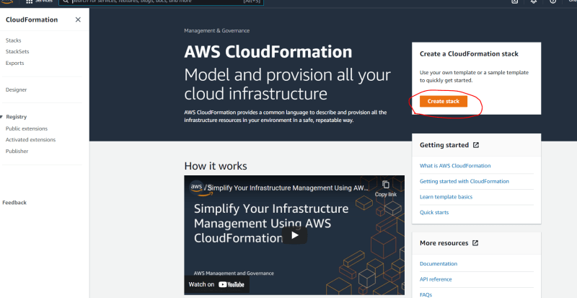  
  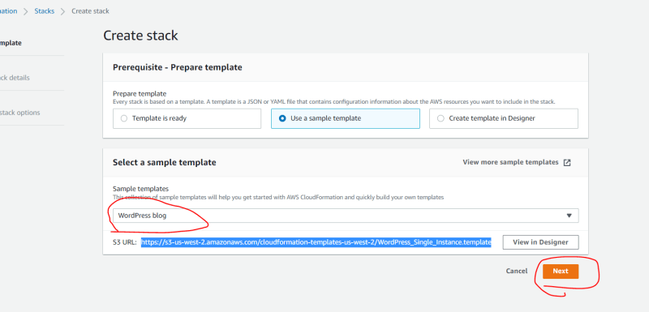  
  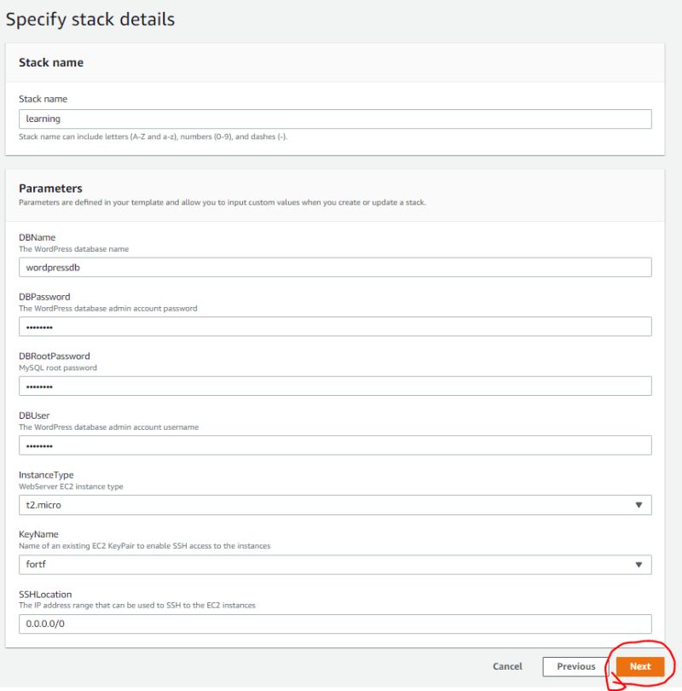  
  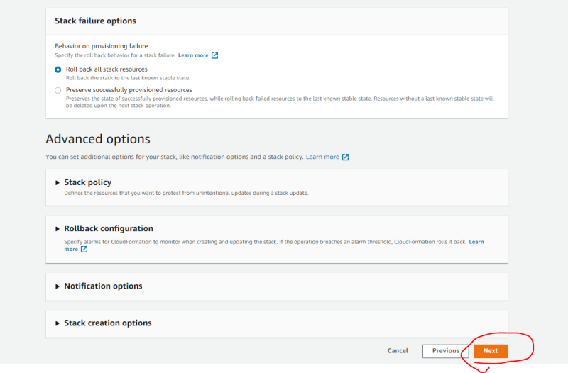  
  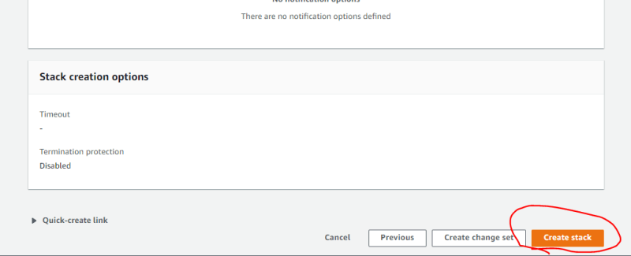  
  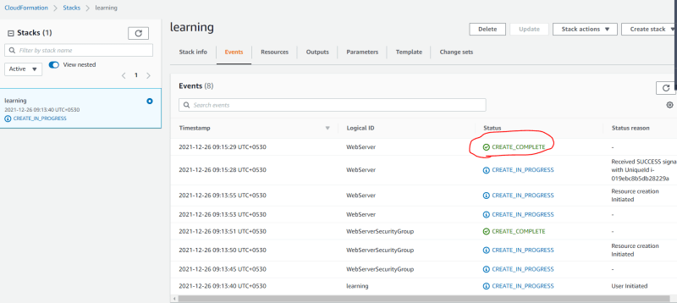  
  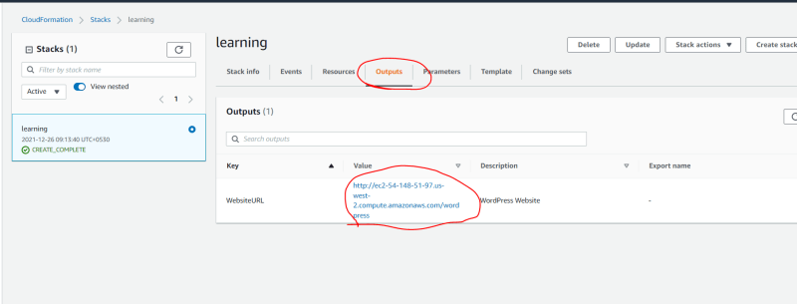  
  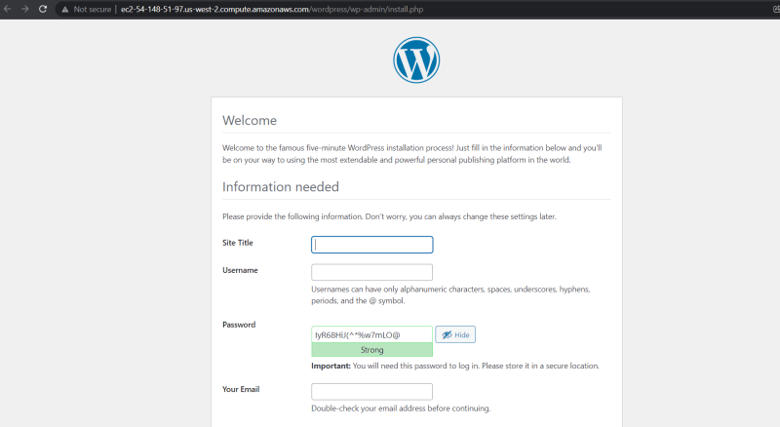
* To deploy word press we have taken some template and created stack, if you have similar template created for your application deployment, will it not be useful for ci/cd and multi environment creations?
* Once you have finished using your application, we can delete the infra by deleting the stack.
* Changes can be made in the deployed infra, by updating a template => updating the stack.

**Authoring CloudFormation Template**

* Developer Setup:
* Ensure Visual Studio Code is installed
* Ensure Cloudformation extension is installed  
  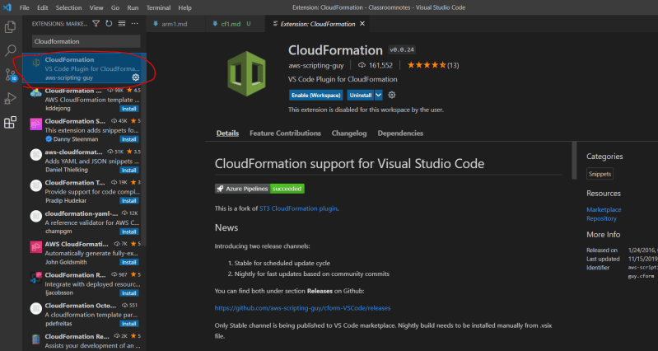
* Template anatomy: <https://docs.aws.amazon.com/AWSCloudFormation/latest/UserGuide/template-anatomy.html> for the official docs
* Cloud formation has a specific structure and the elements are
* AWSTemplateFormatVersion:
  + This the version of the template schema
  + datatype: string
  + value: “2010-09-09”
* Description:
  + A text describing your template
* Metadata:
  + This is an object which provides additional information about the template
* Parameters:
  + Values to pass at runtime
* Rules:
  + Validates a parameter or combination of paramters passed to a template during stack creation or updation process
* Mappings:
  + A mapping of key and associated values
* Conditions
  + Conditions that control wheter a certian resources are created or not
* Transform
* Resources:
  + This is the only required field
  + In this you describe the resource to be created as part of CF Stack creation process.
* Outputs
* Lets try to write our first Cloud formation template to create an S3 bucket
* Manual steps:  
  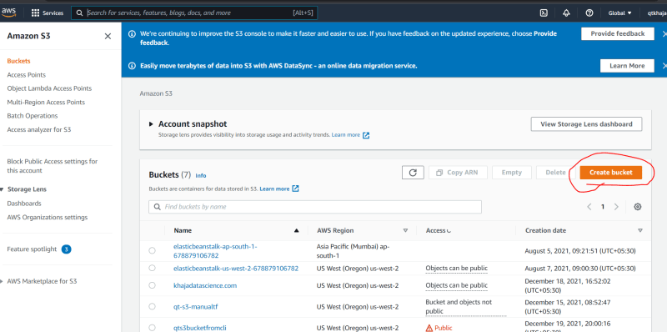  
  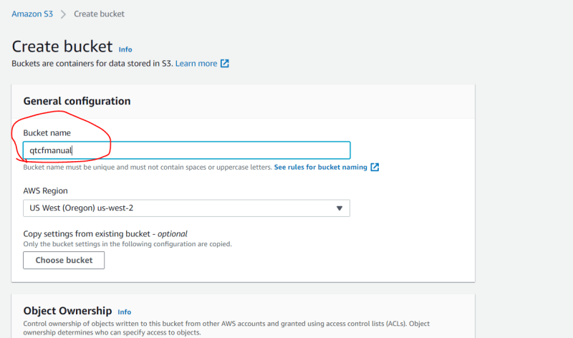  
  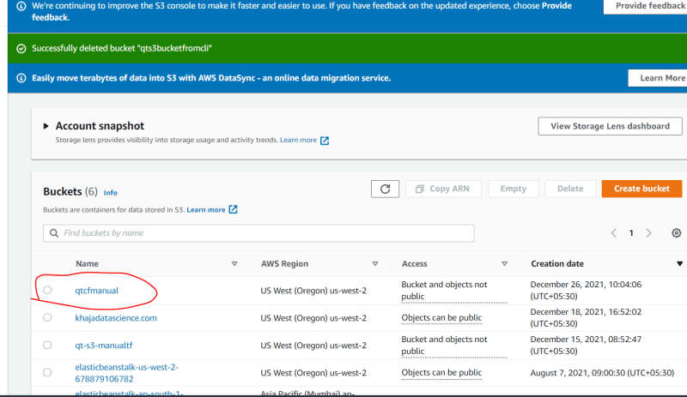
* Lets create a cf template for this.
* To create s3 bucket the resource has the structure as shown <https://docs.aws.amazon.com/AWSCloudFormation/latest/UserGuide/aws-resource-s3-bucket.html>

